Start your summer with Master Classes taught by world-renowned instructors!

Danspace Summer Intensive 2018
With Andra Corvino and Ernesta Corvino
Teen and Adult Division
Beginning through Advanced levels

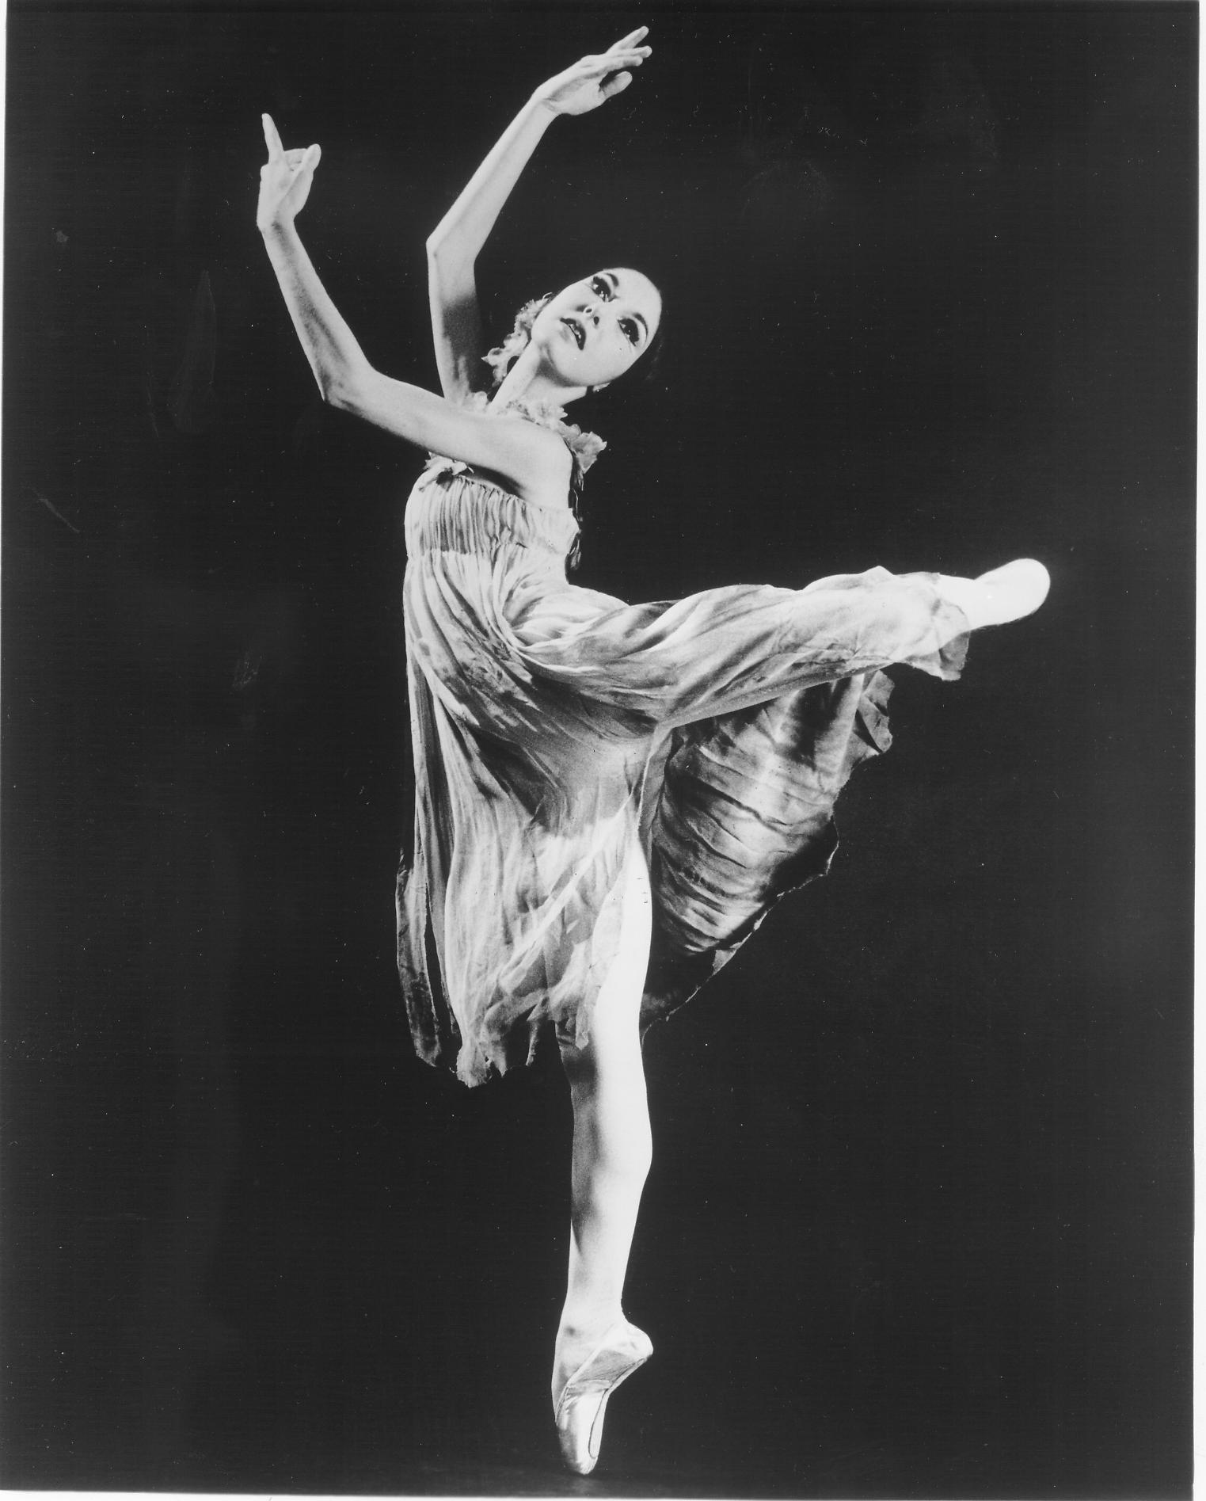
June 18 - June 24, 2018
Monday Through Saturday

See back of flier for
Schedule and pricing information.

Andra Corvino
Juilliard School
(1995-2014)

Ernesta Corvino
Ballet Master for
Jose Limon Dance Company
and Pina Bausch Tanztheater Wuppertal

To Register
Email info@danspace.com

Corvino Ballet Classes reflect the teaching
method developed over the past 50 years,
first by Maestro Alfredo Corvino then
subsequently by his daughters Andra
Corvino and Ernesta Corvino. It is a unique
approach to the understanding, practice
and application of this class art form.
Grounded in the organic principles of
movement, it is anatomically sound,
devoid of affectation, with great emphasis
on musicality.

Danspace was founded in 1976 offering classes for children, teens and adults. Information about its programs can be found at www.danspace.com. The school has been residing at
its location in the Rockridge neighborhood of Oakland, California since 1985.

473 Hudson St. Oakland, CA 94618 510.420.0920 www.danspace.com

Class Schedule

Teen Intensive
June 18 - June 22
Monday-Friday
10:30am-1:00

Tuition: $150 (Ballet and Pointe) or $80 (Ballet only)

Adult Intensive
June 19 & 20
Beginning/Intermediate Ballet 7:30-9:00pm

June 23 & 24
Beginning/Intermediate Ballet, Pointe and Pedagogy
10:30am-4:30pm

Tuition: $175

Unless otherwise indicated, class level is Intermediate/Advanced. Email info@danspace.com with questions about specific classes.

Adult Intensive Drop-in and Package Pricing

Ballet Only (4 classes) =$60
Single Ballet Class = $20
_________________________

Add Pointe to Ballet:
2 Ballet classes & 2 Pointe classes = $60
Single Ballet and Pointe = $40 (Ballet must be taken before Pointe)
_________________________

Pedagogy (must attend both classes):
Saturday, June 23 & Sunday, June 24
2:00-4:30pm

$90

