Intermediate/Advanced Ballet with Beth Hoge
For Teen and Adult Students

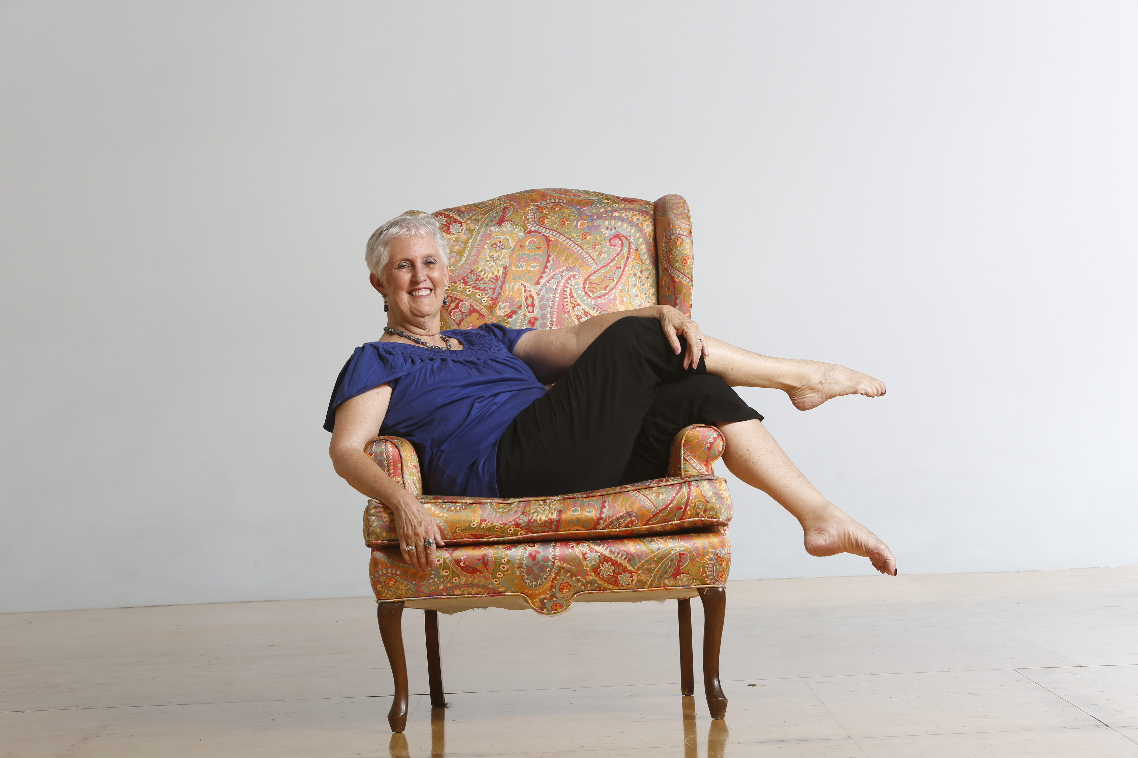

We are pleased to announce that Beth Hoge will be teaching Intermediate/Advanced Ballet on the following Saturdays from 11am-12:30pm in the 2019 spring semester:

February 2nd
March 2nd
May 4th
June 1st

Many of you know that Beth Hoge is our Founder and Matriarch of our community at Danspace. She founded Danspace in 1976 after a long dance career in Los Angeles and New York. While in New York, she attended Julliard and studied with Antony Tudor, Margaret Craske, Martha Graham, and Alfredo Corvino, who was ultimately to become a life-long mentor and teacher. We cherish the work of the Corvino family at Danspace and are continually inspired by the teachings Beth and the Corvinos offer.

Cost per class is $17. We accept cash or check as forms of payment.


Danspace was founded in 1976 offering classes for children, teens and adults. Information about its programs can be found at www.danspace.com. The school has been residing at its location in the Rockridge neighborhood of Oakland, California since 1985.

473 Hudson St. Oakland, CA 94618 510.420.0920 www.danspace.com

