
473 Hudson St. Oakland, CA 94618 | 510.420.0920 | danspace.com
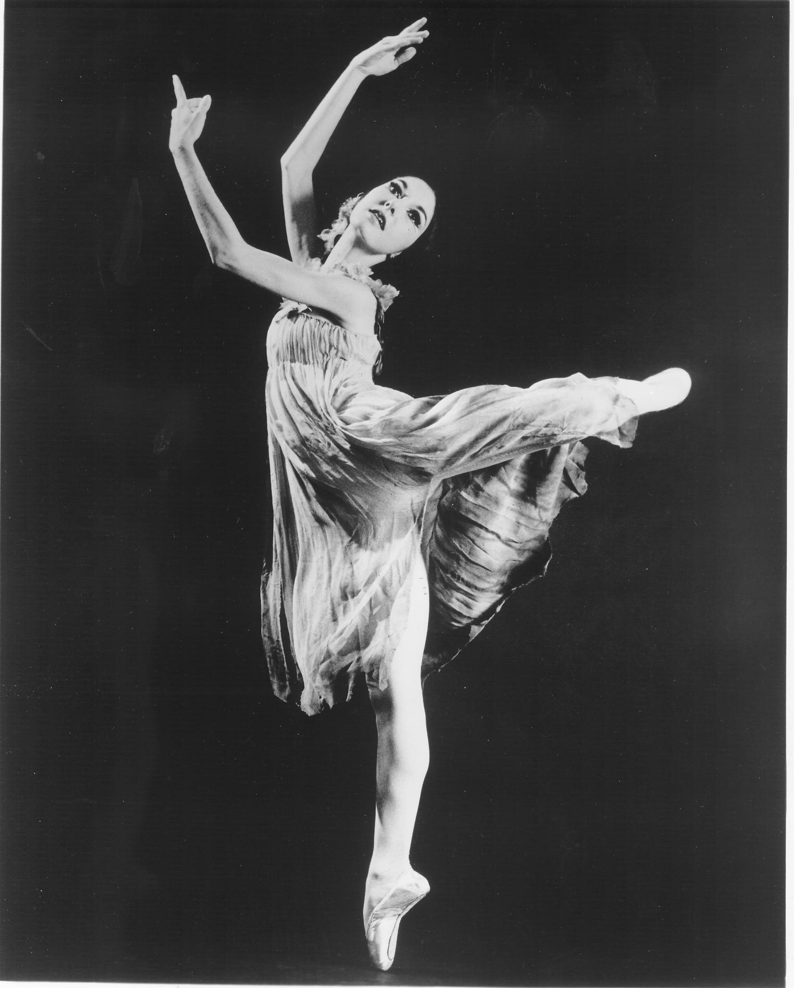


Corvino Weekend Workshop 2026
With Andra Corvino and Ernesta Corvino
at Danspace

Friday, June 12 - Sunday, June 14
Advanced Beginning and Intermediate levels

To register: email info@danspace.com

Pictured: (left) Andra Corvino, Juilliard School (1995-2014), (right) Ernesta Corvino, Ballet Master for Jose Limon Dance Company and Pina Bausch Tanztheater Wuppertal

Corvino Ballet Classes reflect the teaching method developed over the past 50 years, first by Maestro Alfredo Corvino then subsequently by his daughters Andra Corvino and Ernesta Corvino. It is a unique approach to the understanding, practice, and application of this classic art form.

Corvino Weekend Workshop 2026 at Danspace
Email info@danspace.com to register and pay for your classes

Friday, June 12, 2026

11:00-12:30 Ballet
12:30-1:00 Pointe

Ballet class only: $30
Ballet + Pointe: $40

Saturday, June 13, 2026

11:00-12:30 Ballet
12:30-1:00 Pointe
1:00-2:00 Lunch
2:00-3:30 Specialty class or lecture/discussion

Ballet class only: $30
Ballet + Pointe: $40
Specialty class or lecture/discussion: $30

Sunday, June 14, 2026

11:00-12:30 Ballet
12:30-1:00 Pointe
1:00-2:00 Lunch
2:00-3:30 Specialty class or lecture/discussion

Ballet class only: $30
Ballet + Pointe: $40
Specialty class or lecture/discussion: $30

Danspace was founded in 1976 offering classes for children, teens, and adults. Information about its programs can be found at danspace.com. The school has been residing at its location in the Rockridge neighborhood of Oakland, California since 1985.

