
473 Hudson St. Oakland, CA 94618 | 510.420.0920 | danspace.com

Dance Camp for ages 11-16

Monday, July 20 - Friday, July 24
Daily, 9:30am-3:30pm
To register: email info@danspace.com
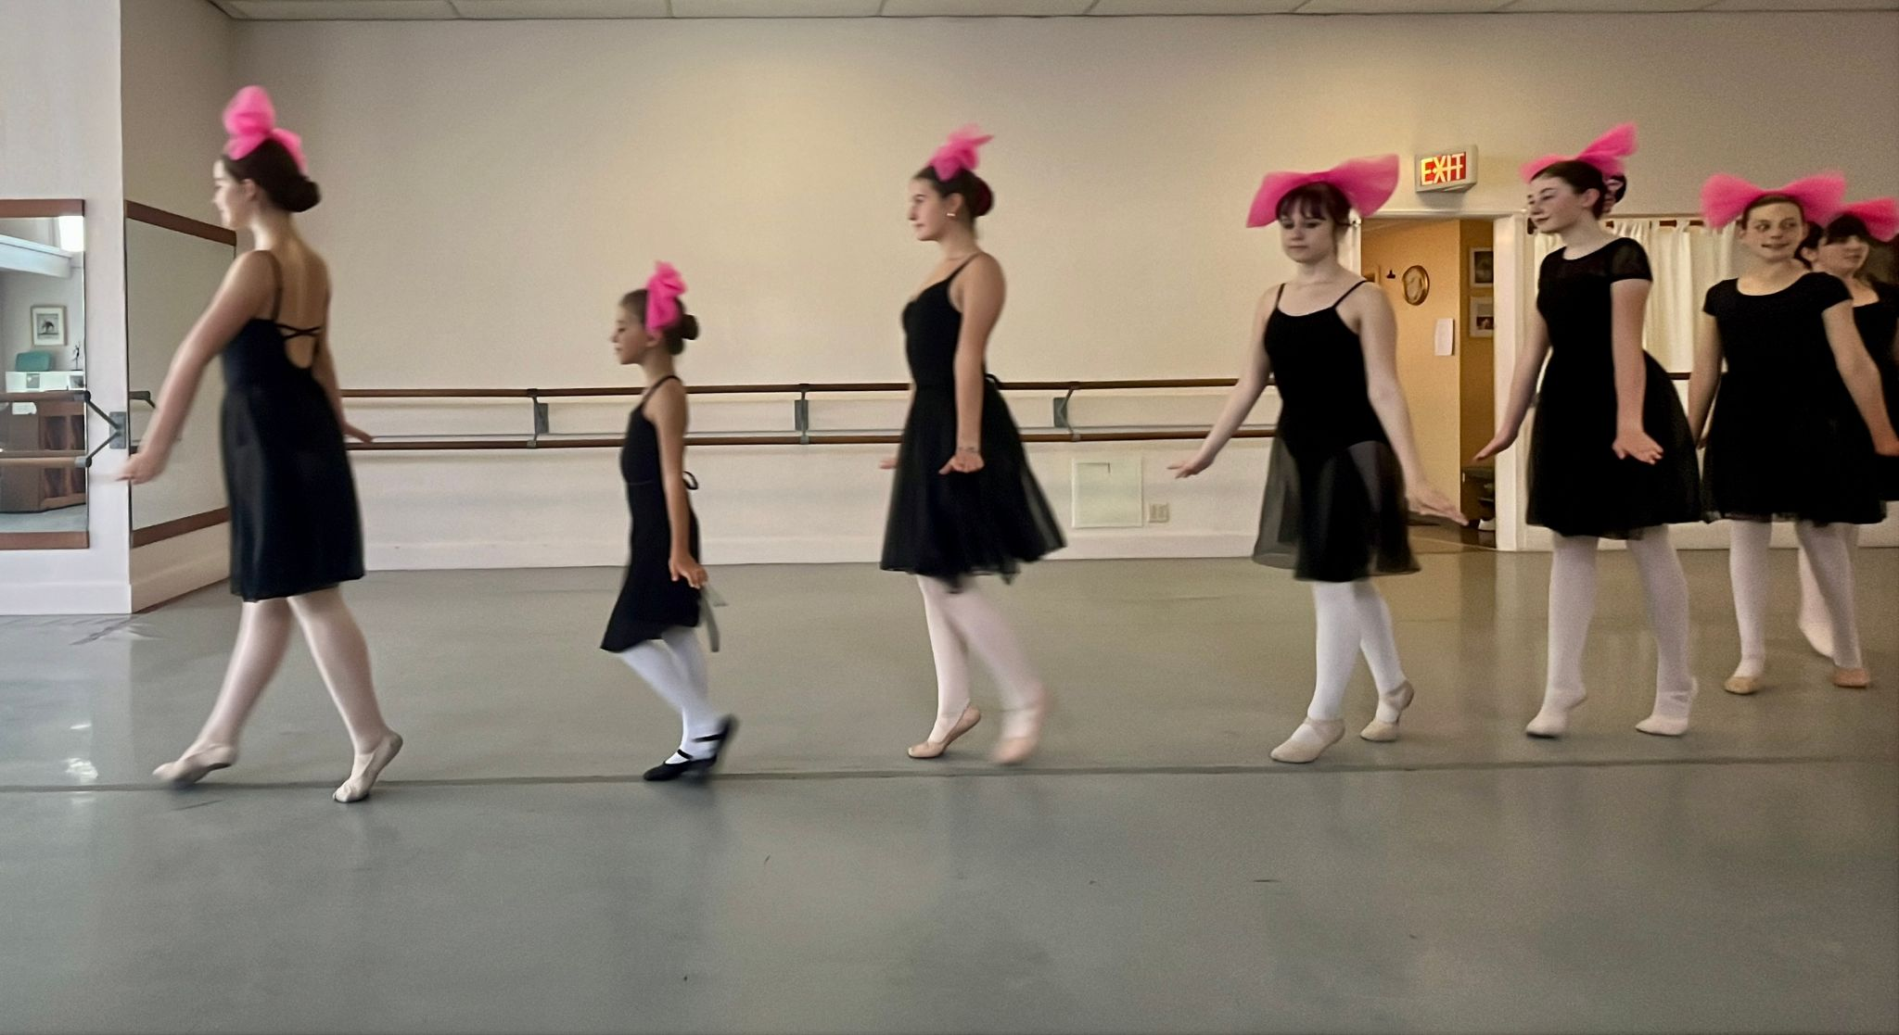

For dancers consistently enrolled in a ballet class or dance program for at least 3 years.

Sample schedule:

9:30-10:15am Pilates Mat, transition to Ballet
10:15-12:00pm Ballet and Pointe
12:15-1:00pm Lunch at Frog Park
1:15-2:15pm Composition
2:30-3:30pm Variations

Danspace was founded in 1976 offering classes for children, teens, and adults. Information about its programs can be found at danspace.com. The school has been residing at its location in the Rockridge neighborhood of Oakland, California since 1985

