Master classes with Beth Hoge at Danspace
Intermediate/Advanced Level Teens and Adults
To register: email info@danspace.com
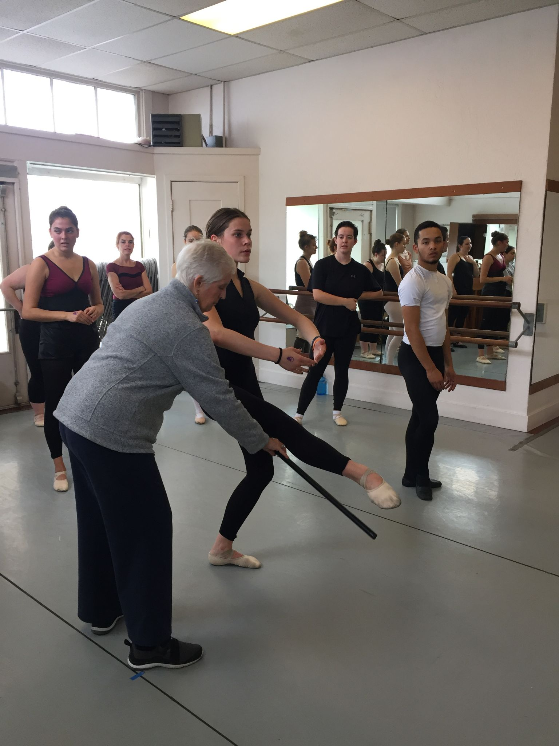

June 1 - June 5, 2026
Monday, Wednesday, Friday
11:00am -12:30pm, Ballet
12:30-1:00pm, Pointe
Tuition Ballet only: $90
Tuition Ballet + Pointe: $120

Classes with Beth reflect a unique understanding,
practice and application of ballet technique -
grounded in the organic principles of
movement as taught by Alfredo Corvino.

Beth Hoge, Danspace Founder/ Master Teacher
aka Beth Brunberg, Beth Jahn, founded Danspace in 1976, after a lengthy dance career in Los Angeles and New York. Her early dance experience included work with Joseph Rickard, in the Southern California Ballet, and with Alicia Alonso and Igor Youskevitch in the Greek Theatre’s summer production of “Giselle.” She then traveled to New York to attend Juilliard. There she studied with Antony Tudor, Margaret Craske, Martha Graham, and Alfredo Corvino who was to become her lifelong mentor, and teacher. While studying at the Metropolitan Opera Ballet School, on scholarship, she performed in the Opera Ballet frequently, appearing with many of the companies who appeared at the Metropolitan: The Royal Ballet, the Bolshoi and the Kirov. She taught Ballet at Mills College from 1983 to 1994 where she made an invaluable connection with the Modern Dance community. The clean, unmannered style, and clear principles of movement based on musicality and efficiency, bridged the gap for many dancers; some continue to study and teach at Danspace today. Others return regularly for class, in support of their careers as dance professionals around the world.


Danspace was founded in 1976 offering classes for children, teens, and adults. Information about its programs can be found at danspace.com. The school has been residing at its location in the Rockridge neighborhood of Oakland, California since 1985.
473 Hudson St. Oakland, CA 94618 | 510.420.0920 | danspace.com

