473 Hudson St. Oakland, CA 94618 | 510.420.0920 | danspace.com


Dance Camp for ages 8-13
For all levels, no experience necessary

Monday, June 22 - Friday, June 26
Daily, 9:30am-3:30pm
To register: email info@danspace.com

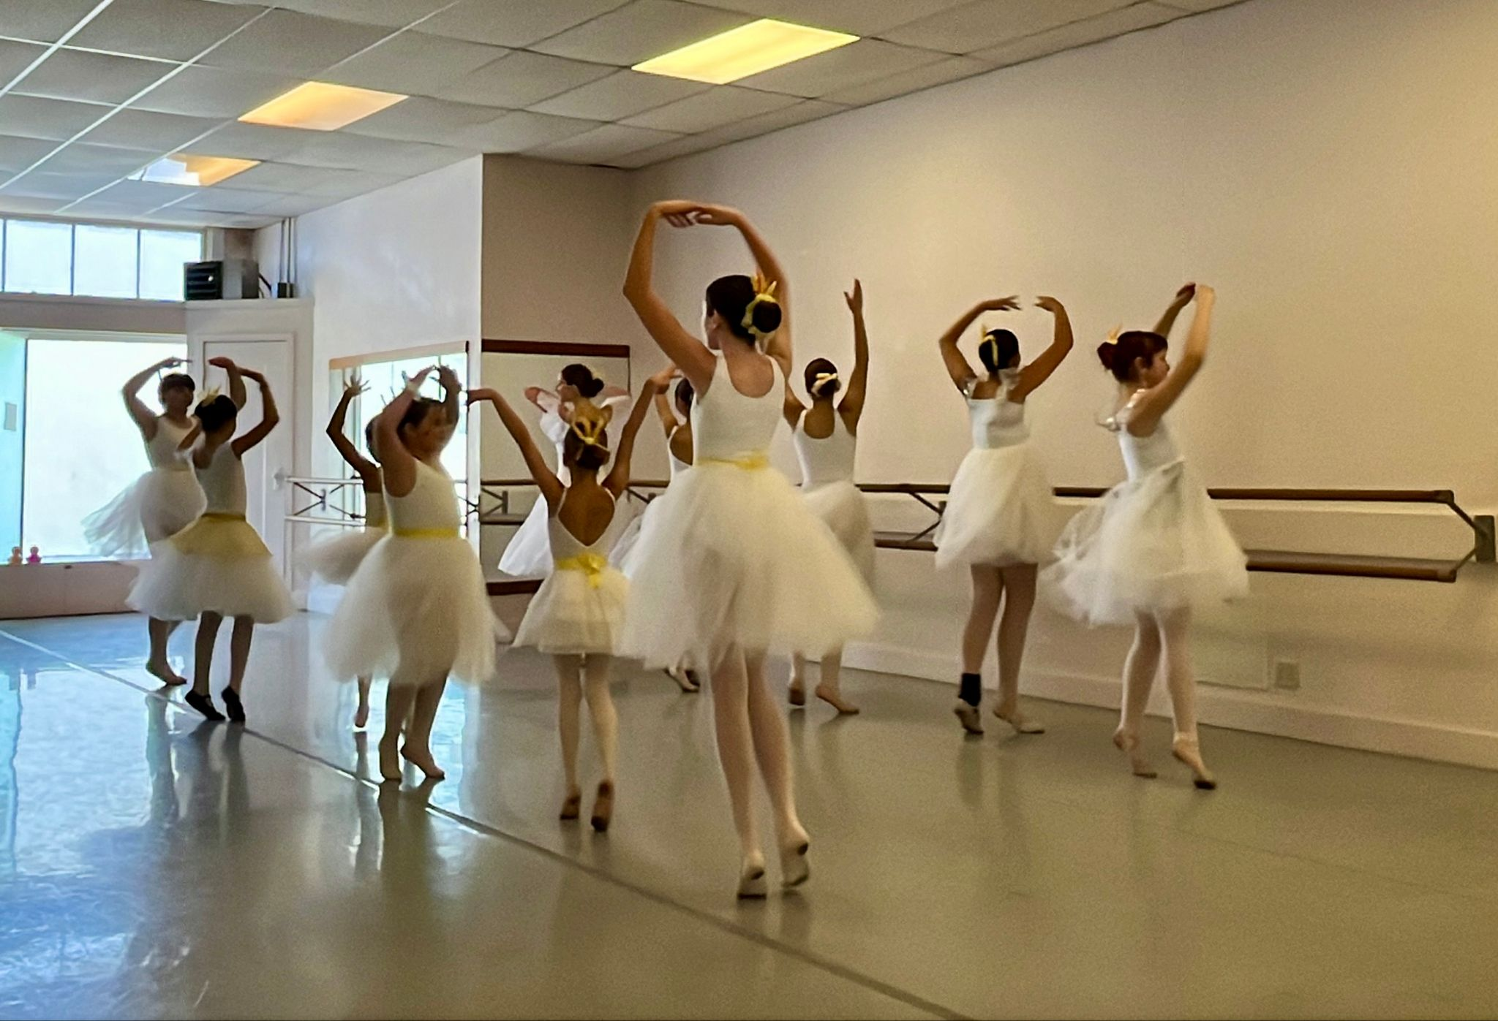
Sample schedule:

9:30-10:45am Opening Circle/Yoga transition to Music Appreciation
11:00-12:15pm Modern
12:30-1:30pm Lunch outdoors at Frog Park
1:45-3:00pm Composition
3:00-3:30pm Closing Circle

Danspace was founded in 1976 offering classes for children, teens, and adults. Information about its programs can be found at danspace.com. The school has been residing at its location in the Rockridge neighborhood of Oakland, California since 1985.

