
473 Hudson St. Oakland, CA 94618 | 510.420.0920 | danspace.com
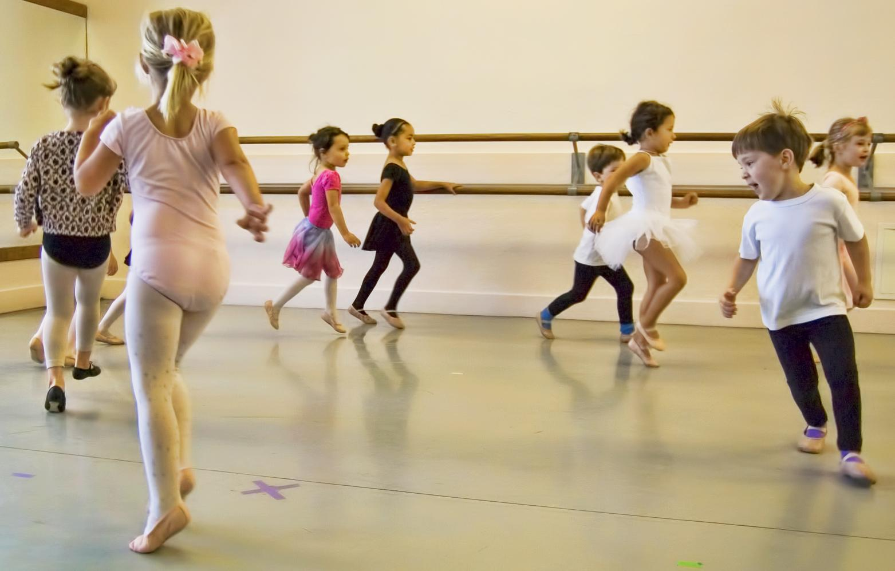
Serendipity and Pre-Ballet
age 3.5-6 and 6-8

Session Dates: July 6 - August 22

To register: email info@danspace.com

Serendipity schedule, ages 3.5-6
Monday, Tuesday or Wednesday from 4:15-5:00pm
Saturday, 9:15-10:00am or 10:00-10:45am (age 5-6)

Pre-Ballet schedule, ages 6-8
Monday, Tuesday or Wednesday from 5:15-6:00pm
Saturday, 10:15-11:00am

Danspace was founded in 1976 offering classes for children, teens, and adults. Information about its programs can be found at danspace.com. The school has been residing at its location in the Rockridge neighborhood of Oakland, California since 1985.

